You can make a Difference
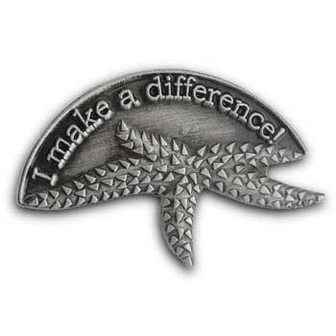
One day a man was walking along the beach when he noticed a boy picking something up and gently throwing it into the ocean. Approaching the boy, he asked, “What are you doing?”
The youth replied, “Throwing starfish back into the ocean. The surf is up and the tide is going out. If I don’t throw them back, they’ll die.”
“Son,” the man said, “Don’t you realize there are miles and miles of beach and hundreds of starfish? You can’t make a difference!”
After listening politely, the boy bent down, picked up another starfish, and threw it back into the surf. Then, smiling at the man, he said, "I made a difference for that one.”

